MYANMAR ROWING AND CANOEING FEDERATION ANNUAL
ACTIVITIES REPORT
ARF Ordinary Congress 15th September 2012, Nanchang, China

Secretary General
Asian Rowing Federation
Date 8th September, 2012
1. Introduction
We would like to acknowledge our sincere thanks and appreciation to ARF on behalf of Myanmar Rowing & Canoeing Federation for inviting us to attend ARF Ordinary Congress on 15th September 2012, Nanchang, China. We also like to congratulate the Chinese Rowing Association for hosting this ARF Ordinary Congress. Myanmar Rowing & Canoeing Federation is affiliated to the International Rowing Federation (FISA), the International Canoe Federation (ICF). The International Dragon Boat Federation (IDBF), the Asian Rowing Federation (ARF), the Asian Dragon Boat Federation (ADBF), the Asian Canoe Confederation (ACC) and the South East Asia Rowing Federation (SEARF).

Our country, Myanmar is outstanding natural beauty and stunning historical sites. It is also recognized by the world as the Golden Land, formerly called Burma. Myanmar’s attractions are rich and varied. They include hundred of ancient temples and golden pagodas, more than 100 different races exhibiting unique characteristics, grand rivers, scenic inland lakes, snow-capped mountains, pristine white-sand beaches and unspoiled archipelagos.

2. Objectives and Specific Goals
2.1 To promote Rowing Sport in Myanmar
2.2 To form Rowing Clubs at State and Divisional level
2.3 Promoting Rowing programmes at Schools and Universities
2.4 To train Junior Rowers in all Clubs with modern Rowing Techniques
2.5 To Organize National Championships, SEA Championships and ASIAN Championships
2.6 To educate and train Coaches to meet the modern techniques of International Rowing
2.7 To increase the number of Trainers, National Technical Officers and FISA Umpires

3. Myanmar Rowing & Canoeing Federation Executive Committee Member
3.1 President U Chit Khaing
3.2 Vice Presidents
1. Prof: Dr. Than Toe
2. U Tun Oo
3. U Maung Win
4. Representative from Navy
3.3 General Secretary U Pe Win
3.4 Treasure U Aye Lwin
3.5 Executive Committee Members
3.6 FISA Umpires U Ohn Myint, Dr. Mon Mon Khaing, U Kyaw Win, U Lin Tha Win,
U Chan Nyein Maung
4. In Myanmar the potential Clubs and Organization are as listed below
4.1 Yangon University Boat Club
4.2 Navy Boat Club
4.3 Yangon Command Boat Club
4.4 Central Command Boat Club
4.5 South West Command Boat Club
4.6 Other Boat Clubs from various Ministries, State and Division.
5. Domestic Rowing Development Activities in Myanmar every
5.1 National Rowing Championships (President Trophy)
5.2 Chief of Staff, Army, Navy and Air force Rowing Championships
5.3 Universities Boat Club Annual Regatta
5.4 Olympic Day Run Regatta
5.5 Inter Navy Regatta
5.6 Selection Regatta for 27th SEA Games
In 9th – 13th May, 2012, FISA umpiring seminar was organized by FISA and MRCF. More than Sixty persons attended. Among them, 4 persons qualified as FISA umpires.

6. London Olympic 2012
One of our women single scullers named Shwe Zin Latt attended in the Asian Qualifying Round. She and one coach participated in the London Olympic 2012.

7. International Events Participation in 2012
7.1 Myanmar rowers were sent abroad for the following events / Competitions
1. Myanmar Rowing Team took 1st in Final B during events in Chungju, Korea.
3. Myanmar Rowing Team will be participate in 27th SEA Games in Myanmar
December 2013 in all Rowing Events.

8. Hosting the 27th SEA Games in Myanmar
In 2013 December Myanmar will be hosting 27th SEA Games at New Capital Nay Pyi Taw and Rowing Sport will be included. Hosting country Myanmar is outstanding natural beauty and stunning historical sites. It is also recognized by the world as the Golden Land, formally called Burma. Myanmar’s attractions are hundreds of ancient temples and golden pagodas.

9. Nga Laik Rowing Regatta Course
A new Rowing Regatta Course will be constructed at the Nga Laik which is a dam located about 25 km north of capital city Nay Pyi Taw. The course will be 2000 M distance, six lanes. Myanmar Rowing and Canoeing Federation shall organize an international Rowing competition in 2012 before SEA Games.

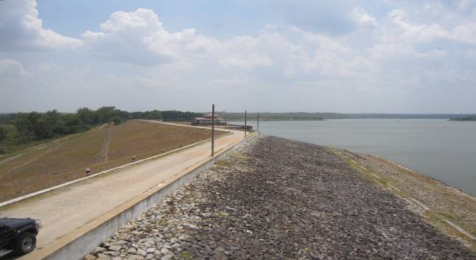
Nga Laik Rowing Regatta Course
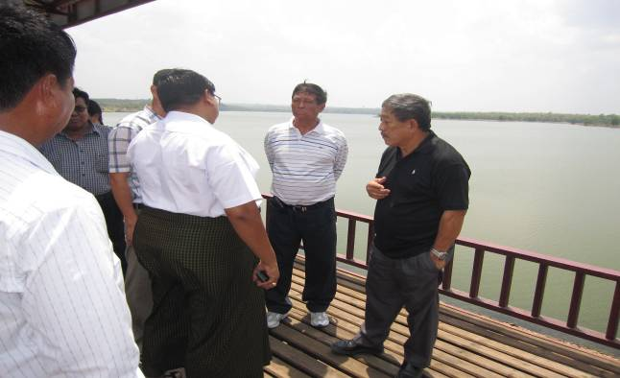

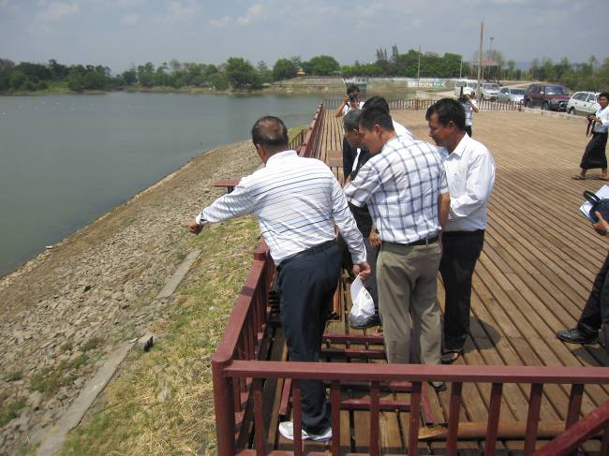

10. Conclusion
Myanmar Rowing and Canoeing Federation will work its best to develop the Rowing Sport in our country and will participate in SEARF Rowing Championships, SEA Games, Asian Rowing Championships, and the World Championships.
As a member of ARF, MRCF will cooperate with ARF to maintain the Rowing Sport for the progress and future success. We also appreciate valuable technical supports from ARF in coming rowing events which will be held in Myanmar. We are pleasured to host the 27th SEA Games in Myanmar and also looking forward to host ARF events in Myanmar in near future.

Myanmar Rowing and Canoeing Federation

